**Criterion B: Record of Tasks & Design**

**Table 1.** the Record of Tasks form

|  |  |  |  |  |  |
| --- | --- | --- | --- | --- | --- |
| Date (Task Number) | Action | Outcome | Time Estimated | Date Completed | Criterion |
| December 17th | Got the idea in the form of a request from the users | Formulated a general plan of what the program is going to look like | 2h | December 18th  See Appendix A-1, meeting notes | A |
| December 20th | Began to figure out the cube | I numbered the faces of the cube to help me figure out cube rotation pattern | 1h 45min | December 20th | A,B |
| December 22nd | Skelton code created | Built the graphics interface  Finished the code for the cube’s moves and functional methods | 5h | December 27th | A,B,C |
| December 28th | Discussion with Linhai and others | To reduce interface clutter, taking out the “jump to step” button and removing some additional moves | 3h 20min | December 28th  See Appendix A-2, meeting notes | A,B,C |
| December 29th | Agreed on showcase date | January 4th is the agreed date. Began programming main class | 8h | January 2nd | B,C |
| January 2nd | Self-testing phase | Found problem in cube rotation, found issues with buttons on interface | 3h 20min | January 3rd | B,C |
| January 4th | Showcase, along with more feedback | Kept all current functions, started to cleanup interface more as well as adding system feedback | 2h 30min | January 5th  See Appendix A-3, meeting notes | B,C |
| January 6th | Programming officially finished | | | | B,C,E |
| March 14th | Filming, editing, and uploading the video on this date | | | | D, E |

**Figure 1.** the hand drawn cube planning sheet (hand drawn for convenience reasons)

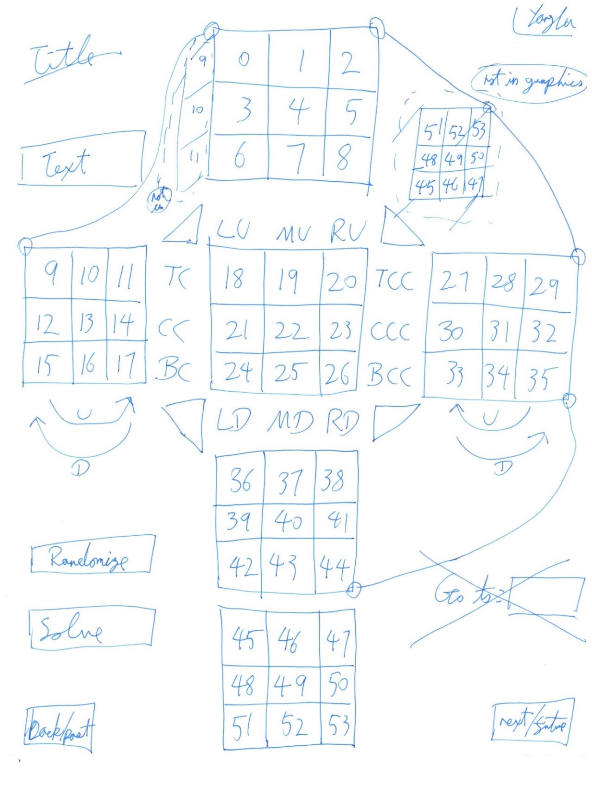

This was not typed up as it just serves the purpose to show the notes of development process. Typed versions can be requested, but they would not give any more insight in the program

**Table 2.** the list of variables and other fields for the graphics portion of the program

|  |  |  |  |
| --- | --- | --- | --- |
| Name | Data Type | Description | Other Information |
| T# (# are 0 to 53)  EG:  T4, T39, T53 | Panels in the graphics program | Just a panel that can change color or show text, used to represent the cube faces | I numbered each of the faces of the cube with its special number to help me keep track of rotation patterns |
| (T,C,B)(C,CC)  EG:  TC, TCC, BCC | Graphics buttons on the left and right of the center cube | Buttons used to rotate the cube | HORIZONTAL:  T = top  C = center  B = bottom  C = clockwise  CC = counterclockwise |
| (L,M,R)(U,D)  EG:  LU,MU,RD | Graphics buttons on the top and bottom | Buttons used to rotate the cube | VERTICAL:  L = left  M = middle  R = right  U = button on top  D = button on bottom |
| Randomize | Java button | Randomizes the cube faces |  |
| Solve | Java button | Basically replaced the records list with the solved list which includes the records list (further down) |  |
| pPosition | Java button | Go to a previous position of the cube if there is one |  |
| nPosition | Java button | Go to the next position of the cube if there is one |  |
| Congratulations | Java graphics label | A simple message is displayed when they successfully solve it |  |

I choose not to list every single panel and every single button I’ve had as it would simply be redundant and would not provide any more useful information in this report. The examples are listed and I feel like they have been explained clearly and concisely.

I have stated that I created the graphics in Netbeans, the table above lists all the things I’ve actually created with Netbeans, along with their general relative positions to each other. Everything past this table was coded completely by myself and is created in Eclipse.

**Table 3.** the list of variables and other fields for the arithmetic executable of the program

|  |  |  |  |
| --- | --- | --- | --- |
| holder | Array List Color | The array list that holds the rubik’s cube as it stands right that moment |  |
| Rubik | Object: cube | This is the cube object that has all the methods to affect it |  |
| Record | Array List of Array List Colors | This is a record of all the existing ArrayList colors, this is used for winding |  |
| Solvedholder | Array List Color | Simply what the original solved cube looks like | Used to compare if it’s finished |
| randomizedrecord | Array List of Array List Colors | This is a record of the cube randomizer, used for solving | Modified later |
| Solvedrecord | Array List of Array List Colors | The record of all steps with the randomized record added in the front | Let’s users reverse through the randomization steps, this new record is substituted in place of the normal record when they click solve |
| moves | Integer | Just a counter for the number of moves |  |
| movecounter | Java graphics label | The textbook to tell the user how many moves they are on right now |  |
| solved | Boolean | Is the cube solved, yes or no |  |

During the actual development of the program, the actual amount of buttons and such would fluctuate, depending on if I wanted to remove features or add more functions as per discussions with the user.

No Word Count Required for this Section